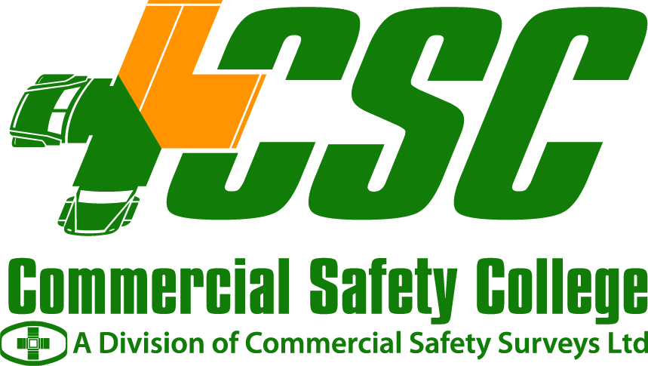

TRACTOR TRAILER INTERNSHIP PROGRAM

INFORMATION PACKAGE

Thank you for your interest in Commercial Safety College. We are confident that you will find that our college offers a wide range of programs and a top-notch professional staff to suit your personal and professional needs.

The following information is lengthy and descriptive to ensure that you are provided with any and all of the information you require to make a well-informed decision. Please do not hesitate to contact us at 1-800-667-5455 or by e-mail at csc@safetycollege.ca if you have any further questions.

Training dates are as follows and are always based on sufficient numbers to run the program.

Start Date | End Date | Internship End Date
January 23, 2012 | March 16, 2012 | April 13, 2012
February 20, 2012 | April 13, 2012 | May 11, 2012
March 19, 2012 | May 11, 2012 | June 8, 2012
April 16, 2012 | June 8, 2012 | July 6, 2012
May 14, 2012 | July 6, 2012 | August 3, 2012
June 11, 2012 | August 3, 2012 | August 31, 2012
July 9, 2012 | September 14, 2012  (Vacation- August 6 -August 17) | October 12, 2012
August 20, 2012 | October 12, 2012 | November 9, 2012
September 17, 2012 | November 9, 2012 | December 7, 2012
October 15, 2012 | December 7, 2012 | January 4, 2013
November 13, 2012 | January 4, 2013 | February 1, 2013
December 10, 2012 | February 1, 2013 | March 1, 2013

What are the admission requirements?

- Pass/Provide a Nova Scotia Driver’s Medical – These forms are available at your local Registry of Motor Vehicle Office and need to be completed by your family doctor.
- Provide a Drivers Abstract – Obtained through your local Registry of Motor Vehicles.
- Must have RMV air brake endorsement.
- Provide a Criminal Search Report – Obtained through your local Police or RCMP.
- Provide a letter of intent from a potential employer indicating that they would consider you for employment upon successful completion of the Tractor Trailer Internship Program, based on qualifications and job availability. ( Note: Anyone with a Criminal Record must have knowledge of this from potential employer and stated in your letter of intent )
- Must be at least 19 years of age.
- Must attend a pre-screening session (more information on pre-screening below).
- Must have held a Class 5 or higher valid driver’s license for a minimum of one year prior to course start date. Any individuals falling under the graduated licensing system “N” must consult the Registry of Motor Vehicles to determine when you are eligible to obtain a Class 1 license.
- Registration fee of $100 is required with Application in the form of a Money Order, Bank draft or Cash. (NO PERSONAL CHEQUES)

Please note: The Nova Scotia Medical, drivers abstract and criminal search are only valid for six months from the date each form is completed. Please make sure your paperwork will still be valid upon completion of your program of choice.

What is pre-screening?

All students are required to attend a pre-screening approximately two (2) to four (4) weeks prior to course start date. This will take three to four hours and consists of psychophysical testing, Test of Workplace Essential Skills (TOWES), an interview, and a brief overview of the program and school policies. These sessions take place two (2) Thursdays each month at 9:00 am. There is a $115.00 fee for the TOWES test which must be paid the morning of the test. The $115.00 TOWES fee is charged by the Trucking Human Resources Sector Council.

Please call to make an appointment for your prescreening session.

How long is the program and what does it include?

The program is twelve (12) weeks in duration. Your first eight (8) weeks of training are done here at the College and your final four (4) weeks of training are done on the road through internship.

The eight (8) weeks of training consist of the following:

- Practical Skills (Field Maneuvering and Rural, Town, City, Trans-Canada Driving)
- Mechanical Skills
- Safety Studies
- Life Skills, Technology Familiarization

What does the four (4) weeks of internship consist of and how is it going to benefit you?

The internship portion of the program is done with a trained coach trained by the College. During the four (4) weeks you will drive with the coach to wherever he/she is going which could include anywhere in Canada and the USA. This is a 12 week program and Internship is highly recommended. If you choose not to take internship you will not complete the program and the cost is the same.

The internship phase of the program is designed to give the student an opportunity to experience many aspects of the transport industry hands on. This includes familiarizing you with border crossing, customer relations, load pick-up and deliveries, map routing, etc., with the added benefit of an experienced coach to guide you.

There are no guarantees of employment; however, many employers see this as an excellent opportunity to determine the drivers’ ability and helps students to “get a foot in the door”. Attached you will find a list of host fleets for the internship phase of the program.

The four weeks that a student will spend on the road gives them on-the-job experience, time in the driver’s seat, and the confidence to commence their new career as a professional tractor-trailer operator.

To be assured a spot in the internship program, you must have an industry accepted drivers abstract and a clean criminal search. This is reviewed at the screening and discussed prior to acceptance into the program.

Student to Instructor Ratios

It is important to know the student to instructor ratios to ensure you are receiving the amount of quality training you deserve. Student to Instructor ratios at our College are as follows:

Classroom twelve-students/one instructor
Field (maneuvering) six-students/one instructor
Road two-students/one instructor

Certifications

Upon successful completion of the program a student would be awarded the following certificates, which are recognized throughout the trucking industry:

- Tractor-trailer operator – Module 1 (awarded after successfully completing initial eight weeks of training)
- Tractor-trailer operator – Module 2 (awarded after successfully completing both eight and four weeks of training)
- Fire Awareness and Live Fire Suppression

The student will also receive the following wallet cards, which are recognized throughout the trucking industry:

- Tractor Trailer Operator | - Transportation of Dangerous Goods
- 20-Hour Air Brake | - CPR/Emergency First Aid
- Hours of Service Seminar | - Border Crossing Seminar
- Professional Driver Improvement Course | - Introduction to Basic Computers
- Federal Motor Carrier Safety Regulations | - Introduction to Basic Forklift Operations

What is the cost of the program?

As of January 1, 2011, the cost of this program is $9696.00. This includes all books and materials that are required, internship fee, and the Training Completion Fund fee. The cost of tuition does not include RMV Test Fees (written & road), room and board, nor does it include any additional monies required while a student is on his/her internship. We have attached a list of accommodations that are available in the area.

In addition, there is a levy of $150.00 which goes to the Trucking Human Resource Sector Council. This is payable upon starting the course.

Note: Tuition payments options are as follows: Money Order, Bank Draft, Certified Cheque, or Cash. (NO PERSONAL CHEQUES)

You will also need to bring a safety vest with you on course or they are available here for an additional $15.00.

Is there any financial assistance available?

Students may be eligible for financial assistance through Employment Nova Scotia (EI). If you are currently receiving employment insurance benefits contact your local EI office to enquire on funding options.

Student loans are also available providing you meet the requirements of the Student Assistance Program. For more information on student loans call 1-800-565-8420 or you can apply on-line at http://studentloans.ednet.ns.ca

Financial institutions (such as banks) are now forming their own student loan programs as well as student credit lines for people who are going to school. Check with your local financial institutions for assistance.

Site Visits

Call today and arrange for a tour of the campus. We always welcome interested individuals to experience our learning environment.

If you have any additional questions, please feel free to contact us at 1-800-667-5455 or by email at csc@safetycollege.ca
Student Application Form
Tractor Trailer Internship (Class 1)

GENERAL INFORMATION
(please print)

Name: ____________________________________________________________

Address: ____________________________________________________________

Postal Code: ______________ Phone Number: _____________________________

Current Class License: (please circle) 5 3 1

Air Brake Endorsement YES NO

Tractor Trailer Internship Program Date: ______________________________________

Education Background

Please circle the last grade completed: 8 9 10 11 12 GED College University

Background Information

Have you had any experience operating either straight truck of tractor-trailer vehicles? If yes, please explain.
_________________________________________________________________________________________________________________________________________________________________________________________________________________________________

Why have you decided to apply for this program? ______________________________________________________________________________________________________________________________________________________

Tuition/Sponsorship Information

Are you applying for sponsorship through Employment Nova Scotia? __________

If yes, what is your counselor’s name and phone number?
________________________________________________________________________

Are you applying for a student loan? _________________________________________

Will you be covering the cost of the program on your own? _______________________

Are the following documents included with your application?

YES NO
Driver’s Medical ___ ___
Driver’s Abstract ___ ___
Criminal Search Record ___ ___
Letter of Intent ___ ___
Copy of Driver’s License ___ ___
Copy of Air Brake Endorsement ___ ___

NOTE: Your application is incomplete without all of the above information. However, it is recommended that you forward the application at your earliest convenience and forward remaining documents immediately thereafter to ensure seat availability. Please call with any questions at 1-800-667-5455.

_________________________________ __________________________________
Signature Date

** Please return completed forms to : Commercial Safety College, P.O. Box 848, Truro, NS, B2N 5G6
OR by fax: 902.662.2657

HOST FLEETS
INTERNSHIP PHASE OF PROGRAM

ARMOUR TRANSPORTATION (MONCTON, NB/HALIFAX, NS)

ATLANTICA DIVERSIFIED TRANSPORTATION SYSTEMS (DEBERT, NS)

CENTRAL FREIGHT LINES (TRURO, NS)

CLARKE ROAD TRANSPORT (HALIFAX, NS)

CONNORS TRANSFER LTD. (NEW GLASGOW, NS)

EASSONS TRANSPORT (BERWICK, NS)

GERALD BATTIST TRUCKING (PICTOU, NS)

HILLMANS TRANSFER (SYDNEY, NS)

KING FREIGHT (PICTOU, NS)

TOM MACDONALD TRUCKING (SYDNEY, NS)

